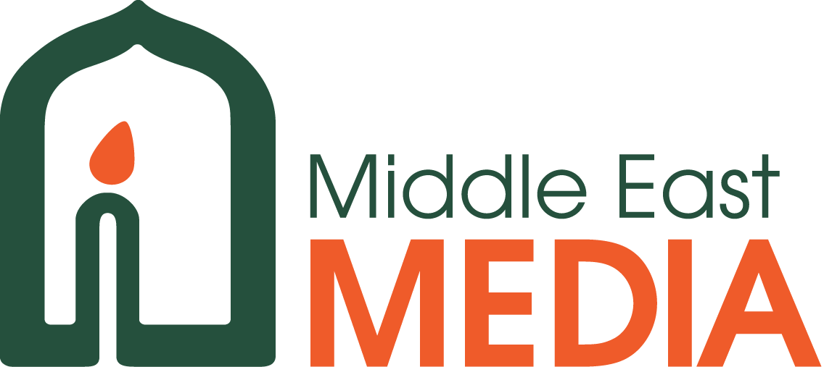

Middle East Media Personnel Needs
Middle East Media is seeking individuals from a variety of backgrounds and experience levels who have a heart for the MENA region to join us for at least one year as we seek to transform lives through media. All applicants must be committed to the purposes and values of Middle East Media. All positions are self-supported unless otherwise indicated and located as noted. Applicants from the region are highly desired, and while knowledge of Arabic is not essential, it would be helpful.
For further information on any of the positions described below, please contact Bob Weszely at bobweszely@mem.org or Jolita Paton at jolita@mem.org
Please visit our website as well www.mem.org to see our latest prayer and praise reports as well as updates on the many projects that we are currently working on in the region.
North Africa Production Office
Long-Term Positions (minimum of one year)
- Fundraising Communications Officer: A native English speaker who can help write proposals and reports that are needed to communicate to our support offices and international donors. Perfect English and good writing skills are necessary. Experience with grant writing is an advantage. Confidentiality is a must.
Short-Term Positions (one-two weeks)
- Technology/media consultants: We need a professional who can look at our media production mechanisms and advise if this is the most updated and affordable way to go about it. But we need someone to have an eye on our working mechanisms and link us to the advanced media technology tools available today given our financial capacity.
- Media trainers: Media professionals who are strong believers are needed to come to Cairo to train groups on the various tracks of media; scriptwriting, camera-shooting, video-editing, 2-D animation, 3-D animation, acting, graphic designing, TV production, audio-engineering, dubbing or language replacement, social media, digital marketing, etc. These training courses are widely advertised on our side and bring trainees from across the region because a “professional foreigner” is a huge attraction.
- Computer Programmer: Our animation team is in great need of the help of a person who is a master of the computer programming language called “Python” who can help them integrate it with their current animation software “Maya”. The integration of those two components correctly can speed their “pipeline” work tremendously.

Gulf Region
Long-Term Position (minimum two years)
- Ministry Project Director and/or Ministry Director
This person would be based in the Gulf, ideally have experience living and working in the region. Initially would be to manage MEM’s current digital ministry from the region, but would ideally expand MEM’s Arabian Gulf ministry activities. English a must, Arabic would be ideal.
- Communications Director
This position requires someone who is highly proficient in writing in English to write proposals, communicate with donors, communicate Gulf prayer and praise items to UK office, attend meetings and conferences, and speak before donors or potential donors as needed.
International Office
All international positions require a commitment to the purposes and values of MEM and a demonstrated ability to work cross culturally, ideally with some exposure if not experience with Arab and Middle Eastern cultures. Ideally co-located in the Middle East Region, some of the positions could be done remotely.

- International Finance Director
This position requires someone who can provide financial leadership within the organization: reviewing, assessing and developing financial policies and practices, recommending industry compliant changes to leadership and implementing all such financial policies for an international organization made up of multiple units in different parts of the world. However, there is need and expectation this person can work directly with consolidation of Int’l accounts, banking, and other basic financial needs of the organization. A respect for and understanding of different cultures and accounting approach’s is needed. This position could be part-time, and the right candidate could include a larger organizational operational and management role. Could be based in Middle East or work remotely from another part of the world, however willingness to travel into the region is a must.

- International Development Director:
The International Development Director (IDD) will coordinate the overall efforts for securing all needed resources for MEM’s ministries across the various teams and will originate and lead MEM Development practice, objectives, and international branding to ensure that MEM maintains a unified approach, with the flexibility for specific needs and communication styles within a specific region or home office sphere. The IDD will also ensure that the overall infrastructure is in place to develop resources and will maintain excellent ongoing relationships with resources partners.

- Communications Director
This position requires someone who is highly proficient in writing in English to write proposals, communicate with donors, communicate Gulf prayer and praise items to MEM’s International offices in other parts of the world. Based on skill sets this person would also create media products, films, audio recordings, visual images that represent MEM’s ministry activities.

MEM Distribution Ministry Director
The goal of this role is to enable the expanded use and thus impact of MEM materials both within the Middle East and with non-Arabic speaking ministries. This will be by making existing media and other resources accessible both for review and ultimately for ministry distribution. Two elements or skill sets are needed for this role that could be filled by one or two people. Both require organizational skills and the ability to take initiative to develop a new ministry activity within MEM.
- Partner/Client relations: To be able to promote and make MEM materials known to potential interested partners, provide review materials, oversee creation of and modify distribution agreements, follow up with partners use of materials and provide feedback to the teams. Coordination of material with field teams regarding what materials are available for what markets and on what conditions. This will include the creation of informational materials that need to be available in both Arabic and English. This is a combination of promotion, relational and administrative detail skills sets with great people skills to find groups around the world that can use our materials as well as find new, cutting edge ways of distributing them.
- Technical and Product management: Responsible to collect all existing and ongoing program in digital format, ensure they are in the correct quality level for review and distribution copies, and posted in secure online locations to which selective access can be given. Includes delivery of final materials, which include video, stills, scripts in appropriate language, etc. Knowledge of, or willingness to learn media formats, online platforms and general technical ability is required.
Knowledge of Arabic would be ideal, in at least one of these roles.

- Theologian & Regional Religion Specialist
The goal of this role is to provide theological and special input on the majority religion within the context for MEM’s programming teams. To work with development and review of theology of change. Expanding MEM’s impact in discipleship before, at and after the cross.

- International Administrative Assistant (IAA)
The IAA will assist the International Office and Director in all areas administratively. He or she will correspond with partners, Arab team field offices and support offices, draft reports and create spreadsheets for financial reports. The IAA will also be able to coordinate digital/virtual communications in shared online spaces. Excellent organizational, computer and online skills are required. The ability to travel internationally on occasion is also a necessity. Excellent English a must – Arabic a plus.

All positions current as of January 2023

